0b

NTCG Chesterfield’ Online

Volume Number 1 2nd Quarter Date April 2012

Welcome...
We’ve changed from being published monthly, to quarterly. I hope you’ll enjoy our new home here on www.NTCGChesterfieldOnline.weebly.com

You can print these pages if you wish to but it must be for your personal use only. Permission has been given to us to use the items and fun things on the pages inside.
So go on, have some fun! Just don’t sell it as your own!

To have your Pictures, Poems, Encouragements, Testimonies, Announcements, Prayer Requests, Greetings, Puzzles, Recipes, Tips etc. in the next publication please email me at ntcgchesterfield@hotmail.com Please add “Submissions” in the subject line.

Last date for entries to be included in our next publication will be Sunday June 24th
From your Editor...

Hello!
Do you have little ones that you read stories to? Well, can I introduce you to our daily bible stories? You can find it here. Remember to go back each day for a new one! There’s also a children’s publication called “Children Worship Too!” which is here.
I hope you and your little one(s) find lots of pleasure in these publications. Why not let me know how you get on? I’d love to hear from you!
Remember, if you have a story, poem, recipe or anything else that you’d like to see in the next edition, send it to me by email, the address is on the front page.

Dates, Events Notifications for Your Diary

Sunday, 1st April (marks the beginning of the Holy Week),
Maundy Thursday, 5th April (a day Christians commemorate the Last Supper)
Good Friday, 6th April (commemorating the crucifixion of Jesus Christ).

“Yesterday has passed and gone
Tomorrow is a mystery
But today is a gift, that’s why it’s call the present”

God’s Word Today

What does the Resurrection mean to you?
By Anushka
All over the country today Christians are remembering the death and resurrection of Jesus Christ. Many would say that Easter Sunday is the most important day in the Christian calendar – although equally there are those who would say that they choose to remember Jesus’ death on a weekly basis when they take Communion. Whatever your personal opinion there is no denying that the resurrection of Jesus is the crux of our faith, and that we should think about it regularly.
Why exactly is the resurrection so important? Jesus sacrificed himself and died for our sins. He was buried, and he was restored to life again. Because of him, we can ask God for forgiveness for our sins, and Jesus acts as a covering for those sins to bring us closer to God.
The apostle Paul sums it up very neatly:
“If Christ has not been raised, your faith is futile and you are still in your sins.” (1 Corinthians 15:17)
Not only that but we have the promise of being resurrected ourselves when Jesus returns to the earth:
“For as in Adam all die, so also in Christ shall all be made alive. But each in his own order: Christ the firstfruits, then at his coming those who belong to Christ.” (1 Corinthians 15:22-23)
Resurrection for me means the hope of eternal life at Jesus’ second coming. Those who have followed Jesus and God during their lifetimes will then be awoken to eternal life in the kingdom that will be set up on the earth.
Have you ever considered what eternal life means? I know that someone at work said to me once that they wouldn’t want to live for ever. But that’s because they are thinking of life in a frail, human body, and life full of human problems, emotional stresses, physical failings, and the problems of those around us. I can quite understand why such an eternal life would not be appealing.
Life in God’s kingdom will not be like that though. He has promised us a fantastic life in the kingdom:
“Then the eyes of the blind shall be opened, and the ears of the deaf unstopped; then shall the lame man leap like a deer, and the tongue of the mute sing for joy.” (Isaiah 35:5-6)
Everyone will be healthy and happy, with no human problems to plague them. We will have the time and energy to give ourselves fully to God.
What will we be doing for all eternity? We are not told all the details in the Bible. The Book of Revelation teaches us about the Millennium age, where for 1,000 years we will be helping to rebuild the earth the way God wants it, but it’s quite vague about what happens for the rest of eternity!
All we know is that God will be “all in all.” He will be in everything, and everything will be for him. We will serve him for ever and ever and we will love to do it! So this says to me that our life now is about learning to love God, learning to serve God, and learning to love doing those things, so that when the kingdom comes it will be a great joy to do those things for evermore.
So if today you have taken bread and wine in remembrance of Jesus sacrifice, and thought about forgiveness of sins, and the hope of immortality through resurrection, let us also consider as we go about our daily lives how we can learn to serve and love God to the best of our ability, and strive to do everything we can to bring about His Glory on earth.

Wishing you all a very Happy and Blessed Easter.

Copyright © 2012 Finding God - All Rights Reserved

John The Baptist Bible Quiz here
Easter is…..
the time for holidays, festivals and a time for giving chocolate Easter eggs.

Pagan traditions give us the English word "Easter" which comes from the word "Eostre". The Anglo-Saxon word for April was "Eostre-monath" (the month of openings). However, it should be remembered that Christians celebrated the resurrection of Christ long before the word "Easter" was used, and the word they used for the celebration was "Pascha", which is derived from and linked to the Jewish festival of Passover.

According to Bede, the English monastic historian, the English word Easter comes from the Anglo-Saxon name for the month of April, which was known as "Eostremonath" in the Anglo-Saxon tongue and since Pascha was most often celebrated in Eostremonath, the English Christians began calling it "Easter". Bede also notes that the month was named after the Anglo-Saxon goddess Esostre.

Rituals related to the goddess Eostre focus on new beginnings, symbolized by the Easter egg, and fertility, which is symbolized by the hare (or Easter bunny).

But Easter means much more....
Origin of Easter - A Christian Commemoration
The origin of Easter, a holiday associated with the observance of the resurrection of Jesus Christ, is actually based on an ancient pagan celebration. Christians recognize this day as commemorating the culminating event of their faith, but like so many other "Christian" holidays, Easter has become commercialized and mixed with non-christian traditions like the Easter Bunny, Easter parades and hunting for Easter eggs. How did this happen?
Origin of Easter - Its Pagan Roots
The origin of Easter dates back to ancient times, not long after the global Flood recorded in Genesis 6-9 of the Bible. Nimrod, a grandson of Noah, had turned from following his grandfather's God and had become a tyrannical ruler. According to the biblical record, as king, Nimrod created Babel, Ninevah, Asshur, Calla and other cities, all known for lifestyles that promoted unspeakable evil and perversion. When Nimrod died, his wife, Queen Semiramis, deified him as the Sun-god, or Life Giver. Later he would become known as Baal, and those who followed the religion Semiramis created in his name would be called Baal worshippers. They became associated with idolatry, demon worship, human sacrifice and other practices regarded as evil.
The origin of Easter involves the birth of Semiramis' illegitimate son, Tammuz. Somehow, Semiramis convinced the people that Tammuz was actually Nimrod reborn. Since people had been looking for the promised savior since the beginning of mankind (see Genesis 3:15), they were persuaded by Semiramis to believe that Tammuz was that savior, even that he had been supernaturally conceived. Before long, in addition to worshipping Tammuz (or Nimrod reborn), the people also worshipped Semiramis herself as the goddess of fertility. In other cultures, she has been called Ishtar, Ashtur and yes, Easter.
The origin of Easter goes back to the springtime ritual instituted by Semiramis following the death of Tammuz, who, according to tradition, was killed by a wild boar. Legend has it that through the power of his mother's tears, Tammuz was "resurrected" in the form of the new vegetation that appeared on the earth.
According to the Bible, it was in the city of Babel that the people created a tower in order to defy God. Up until that time, all the people on the earth spoke one language. The building of the tower led God, as recorded in Genesis 11:7, to confuse their tongues to keep them from being further unified in their false beliefs. As the people moved into other lands, many of them took their pagan practices with them.
Contemporary traditions such as the Easter Bunny and the Easter egg can also be traced back to the practices established by Semiramis. Because of their prolific nature, rabbits have long been associated with fertility and its goddess, Ishtar. Ancient Babylonians believed in a fable about an egg that fell into the Euphrates River from heaven and from which Queen Astarte (another name for Ishtar or Semiramis) was "hatched."
Easter is the oldest and the most important Christian Festival, the celebration of the death and coming to life again of Jesus Christ. For Christians, the dawn of Easter Sunday with its message of new life is the high point of the Christian year.
Easter is the story of Jesus' last days in Jerusalem before his death. The Easter story includes Maundy Thursday (the Last supper leading to the Eucharist), Good Friday (the day on which Jesus was crucified) and Easter Day (the day on which Jesus came back to life).

Origin of Easter - Resurrection Day for Christians
For Christians, the origin of Easter is simply the crucifixion and resurrection of Jesus Christ about 2,000 years ago. According to the Gospel accounts, Jesus Christ, the true Messiah promised in the Old Testament, was crucified and resurrected at the time of the Jewish Passover. Since that awesome event took place, those who believe Christ is their Messiah have honored that day and often celebrated it with the traditional Passover. As the Gospel of Christ spread throughout non-jewish nations, among people who did not have a history of celebrating the Passover, the pagan rites of Easter gradually became assimilated into what the Christian church called "Resurrection Day." Compromising the commandments of God with the comfort of the world is as old as the nation of Israel itself.
Easter Origin - A One-time Event
Easter origin, as a Christian holiday, can be found in the pages of scripture itself. Matthew, Mark, Luke and John, all followers of Jesus, offer their own unique eyewitness accounts of the crucifixion and resurrection of Jesus Christ. It is this culminating event of Christianity that is celebrated on Easter Sunday every year.
Easter Origin - The Resurrection of Jesus Christ
Easter origin actually began as a part of the Jewish Passover, as Christ was crucified and resurrected during Passover week. Christ is believed by Christians to actually be the Passover Lamb spoken of in Exodus, for He Himself became the perfect, sinless sacrifice for the sins of all people. Jews who chose to follow Christ then honored this day in succeeding years during the Passover season, but as Christianity was spread throughout non-christian nations, the celebration of Easter was gradually combined with pagan "rites of spring" traditions. Modern celebrations are the result of this compromise. At the same time, Easter is often the only day that many people attend church and are introduced to the "Good News" of Jesus Christ.
Easter Origin - Christ Revealed in the Jewish Passover
Easter origin can be traced to the Passover ceremony itself. Christian scholars believe that the Old Testament is Christ concealed, while the New Testament is Christ revealed. Let's hold the elements of the Passover up to the light of the life of Christ. By tradition, the lamb to be sacrificed during the Passover was selected four days before the sacrifice was to be made. Jesus rode into Jerusalem four days before He was crucified. The lamb was customarily slain at 3 p.m. on Passover. Jesus uttered the words "it is finished" and died on the cross at 3 p.m. (this is known traditionally as Good Friday, but many Bible scholars have determined the crucifixion to be on a Wednesday or Thursday). The festival of Unleavened Bread began at sunset. One of the rituals involved the sacrifice of a grain offering, representing the first fruits of the harvest. Jesus, according to the Apostle Paul, became the first fruits of those raised from the dead (1 Corinthians 15:20). During the Passover dinner, three matzahs are put together. Christians see these matzahs as representative of the Father, Son and Holy Spirit. The middle matzah is broken, as Christ said at the Last Supper, "This is My body, broken for you." The middle matzah is also striped and pierced, as Jesus was during His crucifixion, and as was prophesied in Isaiah 53:5, Psalm 22:16 and Zechariah 12:10. This matzah is then wrapped in a white cloth and hidden, just as Christ was wrapped in linen and laid in the tomb.
Easter Origin - The Biblical Accounts
Easter (also known as Resurrection Day), is the event upon which the entire Christian faith hinges. Paul, once a Jewish leader hostile to Christians, became a convert when he met Jesus on the Road to Damascus (Acts 9). As an eyewitness of Christ, Paul made it abundantly clear that without the resurrection, there is no basis for faith in Christ: Now if Christ be preached that he rose from the dead, how say some among you that there is no resurrection of the dead? But if there be no resurrection of the dead, then is Christ not risen: And if Christ be not risen, then is our preaching vain, and your faith is also vain. (1 Corinthians 15:12-29)
When Christ was born, He fulfilled a number of Old Testament prophecies concerning the Messiah. By the time of His crucifixion, resurrection and ascension, He had fulfilled more than 300 of them. These numbers alone provide staggering evidence that Jesus Christ was the promised Messiah. So it is with good reason that Christians the world over regard Easter as a very special event. But in the early days of the church, most Christians were Jewish converts. Because Jesus was crucified and rose again during the Passover season, their celebration of Christ's resurrection was acknowledged during that annual observance of the deliverance from bondage in Egypt. Christian Jews (or Messianic Jews) consider the Passover to be symbolic of the time when Christ set all believers free from the penalty of sin (through His death on the cross) and death (through His resurrection from the dead).
Easter is the oldest and the most important Christian Festival, the celebration of the death and coming to life again of Jesus Christ. For Christians, the dawn of Easter Sunday with its message of new life is the high point of the Christian year.
The colour of Easter is white.

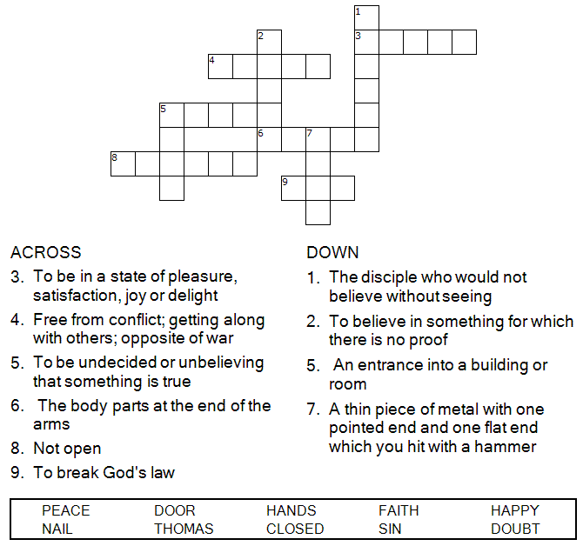

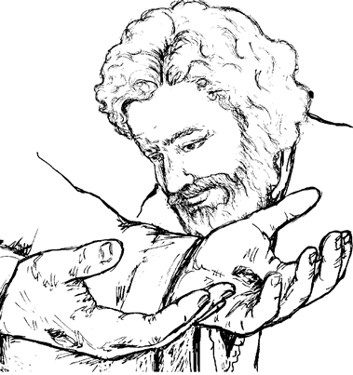

Stare at the four black dots in the center of this picture for about 15 seconds.
Close your eyes and keep them closed until an image appears.
What did you see?

Today's Stress Tip (repeated)

Smile at people.
Note how you feel next time someone smiles at you. Probably welcome, cheered, confident, warm, appreciated. That's the power you have to make others feel, simply by smiling at them. A smile can instantly disarm a bad mood, ease a tense relation-ship, persuade another to cooperate, initiate a friendship. And you always have this potent tool at your disposal. When you smile, studies have shown, good things happen to you, too. You become more relaxed and cheerful. Not to mention the good vibes you'll get from reciprocated smiles. Much too serious and grim-faced? Wear an occasional smile.
Brought to you by courtesy of Third Way Media.

To receive a smile, give one away.

The shortest distance between two people is a smile.
A song to make you Smile
(click on the picture below)

Prayer:
Father in heaven
You are an awesome God. You deserve all glory, honour and praise. Thank You for sending Your son to die for our sake.
Amen

Requests

In your prayers please remember:
Bereaved families
Your communities
The elderly & infirm
Families, neighbours & friends

Visit us online for more inspiration. http://ntcgchesterfield.org/videos.aspx

Click here for your Praise time!

To those celebrating in the months April, May & June
It’s Your Colouring Page to Print – Time to Relax

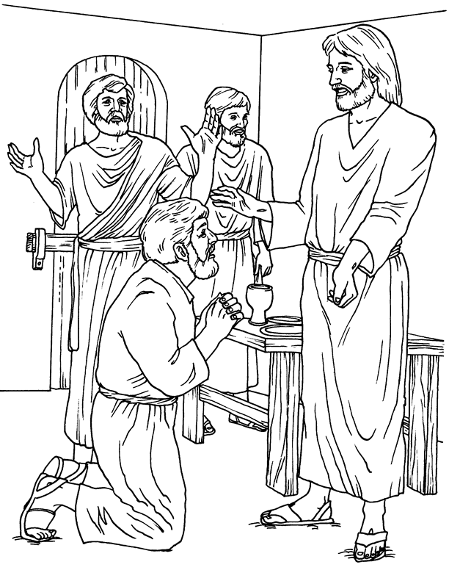
Jesus Appears!
Print to use

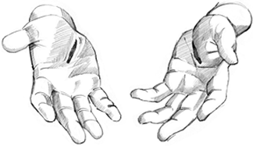

John 20:19-31

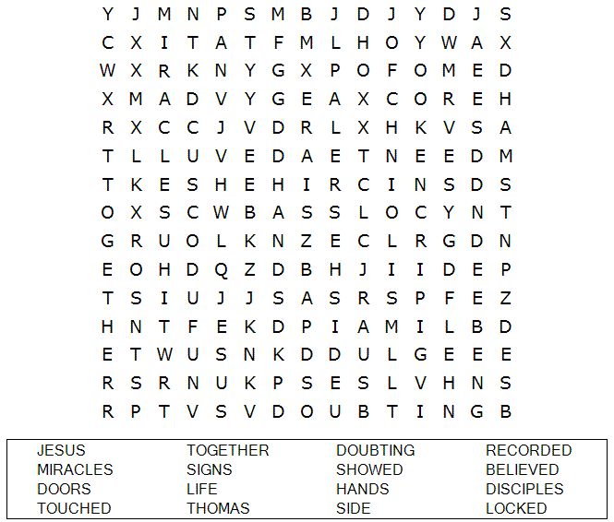

LAUGHTER IS GOOD FOR THE SOUL
LAUGH DOWN YOUR STRESSES
You have to laugh together, and sometimes laugh hard, at yourself, at a situation, at yourselves. Laugh with, but never at, each other...
Prov. 15:13 - A merry heart maketh a cheerful countenance...
Prov. 17:22 - A merry heart doeth good like a medicine

A man and his young son went to church, and when they came out the father was complaining that the service was too long, the preacher was no good, and the singing was off-key.
Finally the little boy said, "Daddy, I thought it was pretty good for a dime."

Got any “funnies” to share?? Email them to me for the next edition.

The Interview With God Poem

I dreamed I had an interview with God.
“So you would like to interview me?” God asked.
“If you have the time” I said.
God smiled. “My time is eternity.”
“What questions do you have in mind for me?”
“What surprises you most about humankind?”
God answered...
“That they get bored with childhood,
they rush to grow up, and then
long to be children again.”
“That they lose their health to make money...
and then lose their money to restore their health.”
“That by thinking anxiously about the future,
they forget the present,
such that they live in neither
the present nor the future.”
"That they live as if they will never die,
and die as though they had never lived.”
God’s hand took mine
and we were silent for a while.
And then I asked...
“As a parent, what are some of life’s lessons
you want your children to learn?”
“To learn they cannot make anyone
love them. All they can do
is let themselves be loved.”
“To learn that it is not good
to compare themselves to others.”
“To learn to forgive
by practicing forgiveness.”
“To learn that it only takes a few seconds
to open profound wounds in those they love,
and it can take many years to heal them.”
“To learn that a rich person
is not one who has the most,
but is one who needs the least.”
“To learn that there are people
who love them dearly,
but simply have not yet learned
how to express or show their feelings.”
“To learn that two people can
look at the same thing
and see it differently.”
“To learn that it is not enough that they
forgive one another, but they must also forgive themselves.”
"Thank you for your time," I said humbly.
"Is there anything else
you would like your children to know?"
God smiled and said,
“Just know that I am here... always.”
-author unknown

I Picked Up a Runaway
Holly Good, Assistant to Lysa TerKeurst
“My people have been lost sheep; their shepherds have led them astray and caused them to roam on the mountains. They wandered over mountain and hill and forgot their own resting place.” Jeremiah 50:6 (NIV)
Devotion:
I picked up a young runaway one afternoon.
She was dirty, wore baggy sweat pants and a yellow sweatshirt, and had muddy feet. I was stopped at an intersection when she sauntered across the street right in front of my car.
I continued on when the light turned green.
But I could not get those bare feet out of my mind. Those muddy, bare feet.
Why was this young girl walking across a busy intersection with no shoes on in the middle of a school day? About a mile down the road I felt the Lord encouraging me to turn around and go find that girl with the bare feet.
It was a gentle, but direct nudge I could not refuse.
I found her several minutes later outside a convenience store with a cup of water in her hand. I pulled up, rolled down my window and said, “Hey, what's going on with you?”
With little emotion she replied, “Oh nothing.”
“Well...what are you doing? Can I take you home?” I offered.
“You can take me to my friend's house,” she answered.
“I'd rather take you home,” I said. “Where do you live?”
“Well, I'm running away from home, so you can't take me there,” she said.
“Oh. Well, I would like to. Where do you live?” I asked again.
She eventually complied and trustingly got in my car. (Oh how my heart was pounding!)
My new friend Sarah was only in 8th grade, skipping school and leaving home because she got into an argument about friends with her parents. She had been gone for two days. The previous night she had slept outside.
I prayed for just the right words to come from my mouth with my fragile but captive audience of one, on the 20-minute ride to her house.
As I dropped Sarah off at her home, I prayed that the Lord would take over from there. I drove off and felt a peace in what He had led me to do that day.
It just so happened that a minor traffic accident had occurred around the corner as I was leaving. So I pulled over and told one of the officers about Sarah, hoping they could also help her in some way.
Find her. Stop her. Detain her. Guide her. Protect her. Save her.
As I prayed for my runaway friend in the days that followed, I realized that she is not much different from you and me. From a place we have journeyed or perhaps a place we are in right now.
Most of us have found ourselves running away at some point in our lives. Running from someone or something. Looking to escape.
Running, yet desperately hoping to be found.
She is lonely. She is angry. She feels betrayed. She feels misunderstood. She feels unloved. She is searching. She is confused. She is bitter. She wants to rest.
Oh my friend, I pray that you will have eyes to see, ears to hear and a place to finally find rest. For you are loved.
You are loved indeed.
Seek Him right now.

Dear Lord, thank You for loving me today and every day. I am grateful that You are bigger than all of my problems. Give me the courage and the wisdom to seek You today, regardless of my circumstances. I want to be found by You Lord. And give me a heart to be able to see and help others near me in need. In Jesus’ Name, Amen.
Related Resources:
Click here to read the follow up letter Holly received from Sarah’s mother.
Do You Know Him?
Application Steps:
Please read Luke 15:11-32. Focus on the father’s actions and reactions and journal your thoughts. What does this story teach you about God’s love for you?
Pray that you will have eyes to see that God’s love is constant, patient and welcoming.
Reflections:
Am I running from something today? Spiritually, physically or emotionally?
How can I seek Him more today?
Read Psalm 71:20-21. Record these verses on a 3x5 card. Do you know someone you could give these verses to as an encouragement?
Power Verses:
Jeremiah 29:14, “’I will be found by you,’ declares the Lord, ‘and will bring you back from captivity…’” (NIV)
Luke 15:32, “But we had to celebrate and be glad, because this brother of yours was dead and is alive again; he was lost and his found.” (NIV)
Jeremiah 33:3, “Call to me and I will answer you and tell you great and unsearchable things you do not know.” (NIV)

© 2011 by Holly Good. All rights reserved.
Proverbs 31 Ministries
616-G Matthews-Mint Hill Road
Matthews, NC 28105
www.proverbs31.org

Are you Seeking God? Or would you like to know more?

The Pastor/Minister of the church that you attend can assist.
Or if you wish to you can contact our Pastor - Reverend Stan Notice on 01246 551906.
Leave your contact details and someone from his office will get back to you as soon as possible.

At the New Testament Church of God in Chesterfield we worship each Sunday at 10:15am for Sunday school, 11:30 for Morning Worship and6:30pm for Evening Worship and on Tuesday evenings we meet for Prayer and Bible Study from 7.30pm.
We want to invite you to come visit us at our church. Our address is 7 Compton Street in Chesterfield near the old football ground.
Find us here

Thank you
&
May God bless you

