NTCG Chesterfield’s
Children Worship Too!
Volume Number 1 1st Quarter Date January 2012

Welcome to...

Hello.....
I’ve been away from “publishing” for a while and I’m sorry if you’ve been missing the editions. The daily bible stories and other activities on the website are still there, with the exception of the published editions which now have a new home. See page 2 for more.

Just a reminder: You can print these pages if you wish to but it must be for your use only.
Permission has been given to use the items and fun things on the pages inside.
So go on, have some fun! Just don’t sell it as your own!

Why not contribute? See the next page on how to do this.

A message from your editor...

Hello!
Well, we’re back and ready for new beginnings
Good news - this and all future publications will now be on this new website, www.NTCGChesterfieldOnline.weebly.com. Unfortunately, publishing will only be quarterly (that’s once every three months) but there will still be lots in them.
Let’s start where we are now, January. Did you know that the month of January is known as the Season of Light? Read more on page 3.
Your usual stories and activities too are included with more songs for you to listen to and learn. So, “go on, get stuck in”!

P.S. If you have a story, poem, recipe or picture/drawing that you’d like to see in “Kids’ Pages”, send it to me by email. The address is ntcgchesterfield@hotmail.com Please add “Kids’ Pages” in the subject line.
I’m looking forward to hearing from you!
****************
Remember, there are still lots of other activity on our web site and a new bible story every day.
Just go to www.ntcgchesterfield.org
What is Epiphany?
The Epiphany is an ancient Christian feast day and is significant in a number of ways. In the East, where it originated, the Epiphany celebrates the baptism of Jesus by John the Baptist in the River Jordan. It also celebrates Jesus' birth.
The Western Church began celebrating the Epiphany in the 4th century where it was, and still is, associated with the visit of the magi (wise men) to the infant Jesus when God revealed himself to the world through the incarnation of Jesus. According to Matthew 2:11 they offered him gifts of gold, frankincense and myrrh.
For many Protestant church traditions, the season of Epiphany extends from 6 January until Ash Wednesday, which begins the season of Lent leading to Easter.
Other traditions, including the Roman Catholic tradition, observe Epiphany as a single day, with the Sundays following Epiphany counted as Ordinary Time.
In the Spanish speaking world Epiphany is also known as Dia de los Reyes (Three Kings Day).
Courtesy of bbc.co.uk/religion/religions/christianity/holydays/epiphany.shtml

The Season of Epiphany
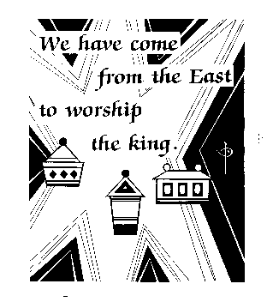
Epiphany, which means to show, is a season of light, when Jesus Christ is shown to be the light of the world. During Epiphany, God is made manifest (made obvious) through the flesh and blood presence of his son, Jesus, on earth.
During the Season of Epiphany, we follow the Wise Men (also called Magi) as they follow the star to Bethlehem to find the Baby Jesus.
The first celebration during Epiphany is the day of Epiphany itself, which Western Christians celebrate on January 6. That day, the festival of light, celebrates the visit of the three Wise Men to the Baby Jesus in Bethlehem. They may have come from the west, perhaps Iran, and followed a star in the sky which led them to Bethlehem.

On January 7, Christians celebrate the baptism of Jesus by John the Baptist in the River Jordan. The Holy Spirit descended from heaven in the form of a dove, the heavens opened, and a voice
spoke, saying, "This is my beloved son, in whom I am well pleased." Jesus was shown to the crowds at the Jordan to be the Son of God.
Jesus was revealed as God on earth in the Transfiguration, when he was shown to be God to his disciples, as he was accompanied by Moses and Elijah on the mountaintop.
Beginning with the star that guided the Wise Men to Bethlehem, God fills the lives of Christians with his holy light during Epiphany so that his light can shine through them into the world.
The colour of Epiphany is green.
Courtesy of sundayschoollessons.com

For some other dates in the Multifath Calendar for the next quarter go here

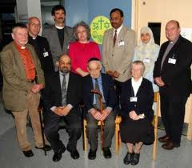
All the Children of the World
Theme: | God does not show partiality. 1st Sunday after the Epiphany - Yr. A
Scripture: | Then Peter began to speak: “I now realize how true it is that God does not show favouritism but accepts men from every nation who fear him and do what is right. You know the message God sent to the people of Israel, telling the good news of peace through Jesus Christ, who is Lord of all. All the prophets testify about him that everyone who believes in him receives forgiveness of sins through his name.” Acts 10:34-36,43 (NIV)
Do you like eggs? There are so many different ways to cook eggs -- fried, scrambled, or hard boiled. You can make an omelette or a breakfast burrito. You can eat them by themselves or mix them with chicken or tuna to make sandwiches. Eggs are also used to make delicious treats such as cookies, cakes, and pies.
Did you know that some eggs are white and some eggs are brown? Have you ever wondered why? Well the answer is quite simple. White chickens lay white eggs and reddish brown chickens lay brown eggs. Is there any difference in white eggs and brown eggs? Well, yes, white eggs are white and brown eggs are brown.
"What about the inside?" you may ask. No, on the inside they look just the same. I also read that the colour of the shell has nothing to do with an egg's quality, nutritional value, or flavour. On the inside, all eggs are the same.
You know, that is true of people too. Some people may be light-skinned and have blond hair and blue eyes. Others may be dark-skinned and have brown hair and brown eyes. On the outside, they may look different, but on the inside they are the same.
Simon Peter was one of Jesus' disciples. He was a Jew and he believed that God sent Jesus only to the Jews. God gave Peter a vision that showed him that He created all people and that He loved them all the same. After God showed him that, Peter said, “I now realize that God does not show partiality. He accepts people from every nation who fear him and do what is right.” God also showed Peter that he must ”tell the good news

that Jesus is the Lord of all and that everyone who believes in him will be forgiven of
their sins.”
Sometimes we sing "Jesus Loves the Little Children."
Jesus loves the little children.
All the children of the world.
Red, brown, yellow, black and white
They are precious in his sight.
Jesus loves the little children of the world.
We sing the song, but do we believe it? Do we show it in the way that we treat other children? I hope so!

Heavenly Father,
Help us to love others as you do -- without partiality. Help us to tell the good news that Jesus is Lord of all and that all who believe in him have forgiveness in his name.
Amen.
ALL THE CHILDREN OF THE WORLD
Unscramble each word, then use the marked letters to reveal the secret word.
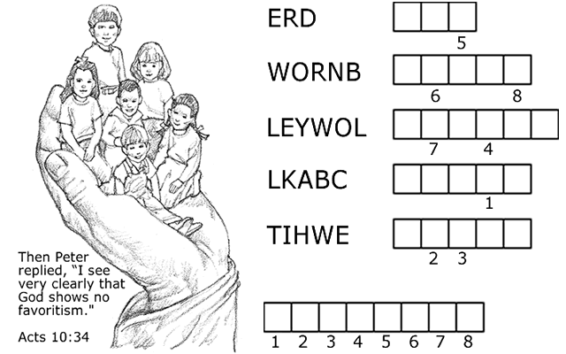
HERE IS A CLUE IN CASE YOU NEED HELP!
All of the scrambled words except the final answer are colours.
"They are precious in his sight!"
Copyright © Sermons4Kids, Inc.
All Rights Reserved
Sermons4Kids.com
Answering the Call
Theme: | Jesus calls us to follow him - 3rd Sunday after Epiphany
Scripture: | And Jesus said to them, "Follow me and I will make you fish for people." And immediately they left their nets and followed him. Mark 1:17-19 (NRSV)

What do you do when there is an an emergency? Let's say, for example, that someone has a serious injury or illness, and if they don't get help right away, they might die. What would you do? Right! You'd pick up the phone and call 9-1-1! (Substitute the appropriate emergency number for your area.)
When you call 9-1-1 and tell the person who answers that you need help right away, it is their job to see that you get help. That person would never say something like, "I'm sorry, we are really busy right now, maybe some other time." No way! They drop whatever they are doing and make sure that you get the help you need.
In our Bible story today, Jesus was walking along beside the sea of Galilee preaching the good news of God when he made a call for help. He saw Peter and Andrew throwing a net into the water, because they were fishermen. He called out to them, "Come, follow me and I will teach you how to fish for people." You see, Jesus wanted Peter and Andrew to help him teach people about God's love for them. When Jesus called Peter and Andrew, they didn't say, "Not right now, we are busy fishing. Maybe some other time." No way! The Bible tells us that they left their nets and followed Jesus.
Jesus, Peter, and Andrew had gone a little farther when they saw James and John sitting in a boat mending their nets. When Jesus saw them, he called to them, Follow
me." They didn't say, "Not right now, we're busy mending our nets. Perhaps some other time." No, the Bible says that they left their father sitting in the boat with the hired hands and followed Jesus.
Jesus is still calling for help today. He has called you and me to help him to bring others into God's Kingdom. Is it an emergency? It sure is! It's a matter of life and death! The Bible says, "Unless you repent, you will all perish." (Luke 13:3) Jesus has called us, what will we say? What will we do? I hope and pray that we will drop whatever we are doing and answer the call.

Dear Jesus,
We want to be faithful to answer your call. We want to fish for people -- just like Peter, Andrew, James, and John.
Amen.
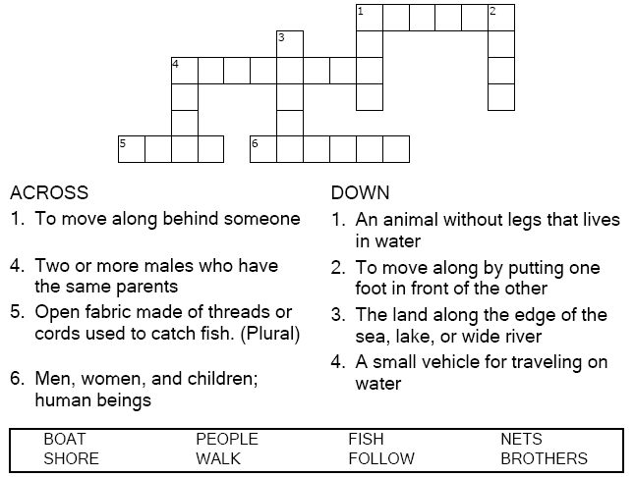
Copyright © Sermons4Kids, Inc. May be reproduced for Ministry Use

Mark 1:14-20

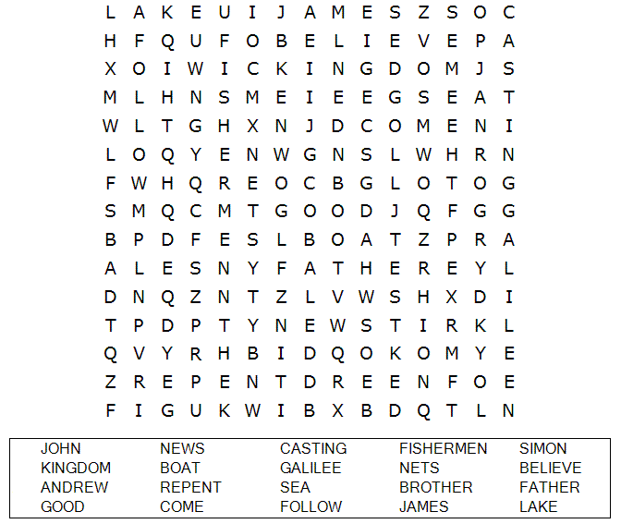 Copyright © 2001-2012 Sermons4Kids, Inc.
All Rights Reserved
The "Bee Attitudes"
Theme: | We find true happiness in Jesus.
Scripture: | Matthew 5:1-12
Have you ever watched a bee buzzing around in a flower garden? As you watch that bee, you will see that he isn't worried about a thing in the world. He is too busy enjoying all of the beautiful flowers that God has provided for him. He is as busy and as happy as a bee can be.
If I were to ask you to tell me what makes you happy, what would your answer be? Would it be something like "happiness is scoring the winning goal in a soccer game" or "happiness is being the most popular person in my class?"
We all want to be happy, don't we? Does it surprise you to know that God wants you to be happy? Well, he does, but you might be surprised to find out that what Jesus said about happiness is quite different from what you and I might expect. Most of us think that to be happy means having a lot of money, having plenty to eat, having someone to take care of us, or being well-liked by everyone. That isn't what Jesus said.
One day Jesus went up onto the side of a mountain. He sat down, gathered his disciples around him, and began to teach them about happiness. Even though these are not the exact words Jesus used, I think they will help us to understand what he taught.
He said things like:
Be happy when you are poor in spirit, because then you will find that your riches are in the kingdom of heaven.
Be happy when you feel you have lost what is most dear to you, because it is then that you will feel the love of the One who is the most dear to you.
Be happy with what you have, because then you will find that your heavenly Father provides everything that you need.
Be happy when you are hungry for the things of God, because then you will find that only He can satisfy.
Be happy when you are caring for others, because it is in caring for others that you will find that you have a heavenly Father who cares for you.
Be happy when your heart is right with God, because it is then that you will see that God is at work in the world around you.
Be happy when you help others to get along peacefully with one another, because it is then that you will know the peace that comes from being a part of the family of God.
Be happy when others treat you badly because you follow me, because your reward will be great in heaven.
You see, happiness is not a feeling that is brought about by the things that happen to us. It is an attitude that we have because of what we have in our heart. We need to be like the bee, buzzing happily through life because of what God has done for us.
Dear Father, help us to have the happiness that you want for us. Happiness that comes, not from what happens to us, but from what happens inside of us. In Jesus' name we pray, amen.

Dear Father,
Help us to have the happiness that you want for us. Happiness that comes, not from what happens to us, but from what happens inside of us. Help us to place our trust in you so that we may experience the happiness that only you can bring. In Jesus' name we pray,
Amen.
Copyright © 2001-2010 Sermons4Kids, Inc.
All Rights Reserved

Songs for you to learn & worship
Song: "Jesus Loves the Little Children" - George F. Root
Song Sheet (PDF) - Music and lyrics
Piano Accompaniment (MP3) Right click and save to your computer.

Song: "Fishers of Men"
Words and Music (pdf)
MP3 Accompaniment Track

Song: "I Love to Tell the Story " - Katheine Hankey & William G. Fischer
Song Sheet (PDF) - Music and lyrics
Piano Accompaniment (MP3) Right click and save to your computer.

These song may be freely downloaded and reproduced for religious or educational use by churches, schools, home schoolers, and other non-profit organizations.
About Carol Williams
Carol and her husband have been in the ministry for 32 years. They have served churches in Illinois, Minnesota, Mississippi, Michigan, and for the last 13 years in Indiana. Carol loves to work with children so you will find her teaching in Junior Church and children's Sunday School. She also has clowning ministry in which she is known as Bubbles tc (the clown).
Copyright © 2001- 2010 Sermons4Kids, Inc.
All Rights Reserved
Sermons4Kids.com
Each number represents a letter of the alphabet. Substitute
correct letter for the numbers to reveal the coded wor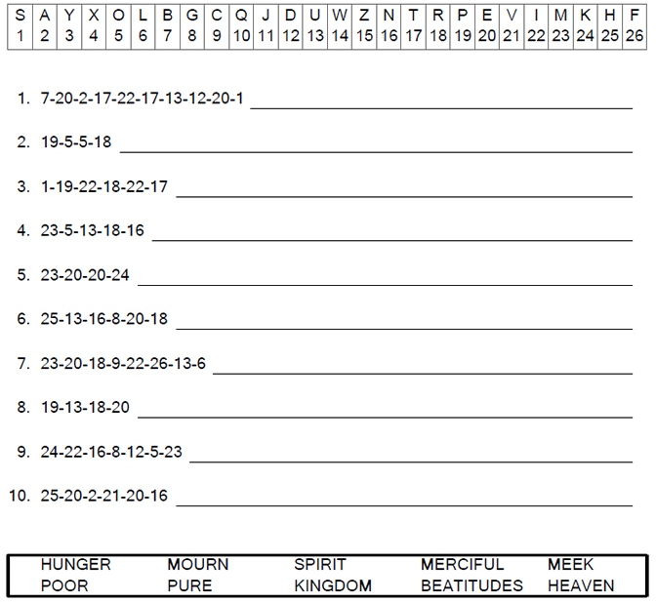
2 pages for you to print & colour

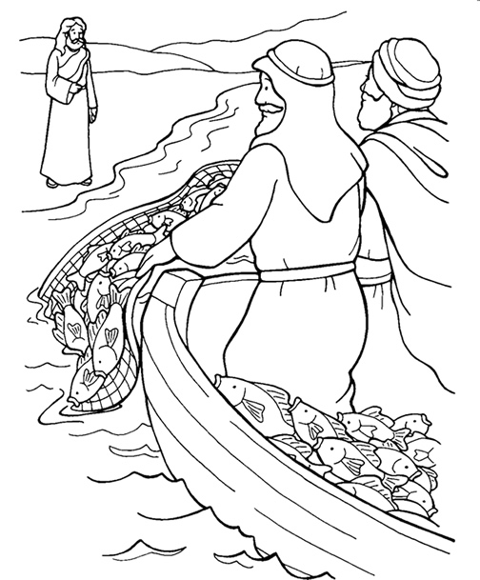
Jesus called out to them, "Come, be my disciples and I will show you how to fish for people! "Mark 1:17 (NLT)
I can tell my friends about Jesus

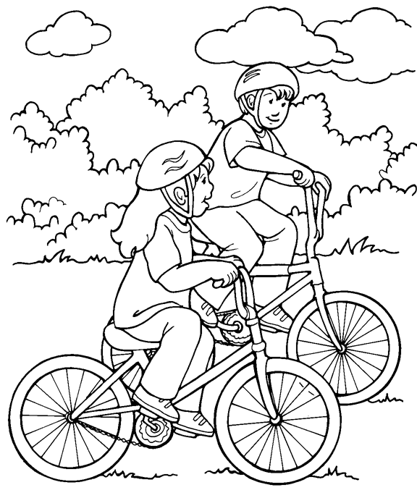
Copyright © 2001-2012 Sermons4Kids, Inc.
All Rights Reserved

We’d like to hear from you...
Send your jokes (clean ones please!), funny stories etc. to us. Our address is on the last page. Go on, make us laugh!

To all who are celebrating this month, we’d like to say...

Prayer Page

Dear Jesus,
Thank You for the sunshine and the rain. Thank You for the gift of the breathe of life.
Amen
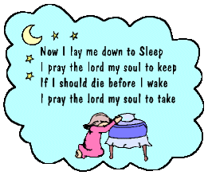

Remember: you can also say a prayer for
Your friends
Your family
Your neighbour
Your teacher
And anyone else you may wish to pray for.
Here are dates you may want to remember

Valentine’s Day
Feb 14th

Ash Wednesday - the beginning of Lent
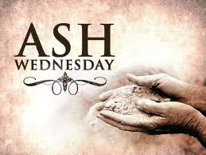
Feb 22nd

Mother’s Day
March 18th

Would you like to know more about God?

Your Youth Pastor/Minister will help, if you don’t have one, you can contact our Pastor - Stan Notice on 01246 551906. Leave your contact details and someone from his office will get back to you as soon as possible.

At the New Testament Church of God in Chesterfield we worship each Sunday at 10:15am for Sunday school, 11:30 for Morning Worship and6:30pm for Evening Worship and on Tuesday evenings we meet for Prayer and Bible Study from 7.30pm.
We want to invite you to come visit us at our church. Our address is 7 Compton Street in Chesterfield near the old football ground.
Find us here

Thank you, have fun, be safe
&
God bless you!!!

