0b

NTCG Chesterfield’ Online

Volume Number 1 3rd Quarter Date July – September 2012

Welcome...
We’ve changed from being published monthly, to quarterly. I hope you’ll enjoy our new home here on www.NTCGChesterfieldOnline.weebly.com
You can print these pages if you wish to but it must be for your personal use only. Permission has been given to us to use the items and fun things on the pages inside.
So go on, have some fun! Just don’t sell it as your own!
To have your Pictures, Poems, Encouragements, Testimonies, Announcements, Prayer Requests, Greetings, Puzzles, Recipes, Tips etc. in the next publication please email me at ntcgchesterfield@hotmail.com Please add “Submissions” in the subject line.
Last date for entries to be included in our next publication will be Sunday September 24th

From your Editor...

Hello!
Do you have little ones that you read stories to? Well, can I introduce you to our children’s publication called “Children Worship Too!” which is here.
I hope you and your little one(s) find lots of pleasure in these publications. Why not let me know how you get on? I’d love to hear from you!
Remember, if you have a story, poem, recipe or anything else that you’d like to see in the next edition, send it to me by email, the address is on the front page.

“Yesterday has passed and gone
Tomorrow is a mystery
But today is a gift, that’s why it’s call the present”

Dates, Events Notifications for Your Diary

Please click banner for more details

2012 Olympic Games – starts 27 July - 12 August
Find out more here
2012 Paralympic Games – starts 29 Aug - 9 Sept
Find out more here

Canada Day
Canada day is a day for Canadians to Celebrate independence. It is celebrated on July 1st unless that date is a Sunday in which case it is celebrated the day after. On July 1st of 1867 the queen of England gave them independence.

United States Independence Day
The Independence Day referred to here is the U.S. Independence Day also known as the "4th of July" that commemorates the adoption of the Declaration of Independence. It is a Legal U.S. Holiday that is celebrated with picnics and fireworks.

Bastille Day
Bastille Day is celebrated on July 14th each year to commemorate the anniversary of the storming of the Bastille starting the French Revolution 1789 and the uprising of the modern French nation.

A list of independence days of countries around the world can be found here
More about National Days around the world can be found here
Ramadan (Muslims) begins – July 20th A month of fasting from dawn to sunset
Harvest Festival (Christian) – Lammas celebration of the 1st Fruits August 1st - September 23rd
Raksha Bandhan (Hindu) 2nd August – Festival that celebrates brotherhood and love
The Transfiguration (Christian) 6th August
Jamaican Independence Day 6th August

Please click banner for more details
20 - 23 August 2012
A summer boot camp for boys. Get your young men ready for a life changing experience!

Turning Your Pain into Purpose
Cindi McMenamin

Is God withholding something from your life? If so, it could be that He is preparing you for ministry - a ministry that will turn the bitter areas of your life into a blessing.
That's how it worked with Nicole.
Nicole couldn't imagine her life being complete without a husband.
"All my life I've wanted a healthy partnership with a spouse who was also my best friend," Nicole says. "Even as a child, I dreamed of finding my 'Prince Charming' and building a life with him."
So Nicole went after what she wanted...and ended up regretting it.
"During college, I clung to the first guy who paid attention to me, even though I now recall the Lord calling me away from him."
At that time, Nicole didn't have a relationship with God and she continued to cling to an unhealthy relationship out of fear of being alone, even though she was being neglected and emotionally abused. After several years of dating, she became pregnant and she and her boyfriend married.
"This was a do-it-yourself project that failed miserably!" Nicole said. "When my daughter was 2, my husband admitted to having an affair and I was brought to my knees.
"I turned my life over to the Lord at that point and tried to be a godly wife, but he was openly opposed to my relationship with God and eventually left during our seventh year of marriage.
"While I will never regret having my beautiful daughter, I do regret not trusting God enough to walk away from this unhealthy relationship that cost me many years of pain, not to mention a lot of turmoil for our daughter. Looking back, I see why I can fully trust the Lord when He withholds something from us, even if we think it's what we want. I've learned the hard way that 'Father knows best!'"
Nicole is in her mid-30s now and has been single for almost five years. She has gone through a spiritual recovery program, as well. But, she says, "The Lord continues to withhold dating relationships from me."
A couple years ago, Nicole decided it was time to no longer fight her circumstances but to see what God wanted to do in her life, in spite of them. Along with a widow and a divorced mom from her church, Nicole began a ministry called Single Parent Fellowship (SPF) at her church.
"Although I was initially hesitant about starting it, this ministry has blessed me beyond my dreams and we are now being led and ministered to by a family pastor at our church who has taken us under his wing."
The group meets weekly for prayer, parenting book discussions, Bible reading, and fellowship. They also plan activities together like movie outings, ice skating, camping, and trips to the mountains together. One Christmas the church bought and delivered Christmas trees to all the homes of those involved in the ministry. "We have all become extended family and I am happier now and less alone than I was when I was married!" Nicole says. "More importantly, the Lord has forever changed my heart for single parents. He is even using me now at my workplace to encourage other young, single moms in their journeys."
What caused Nicole to go from merely surviving to thriving as a single mom? What turned her desperation for fulfillment into a desire to serve others? She allowed God to meet her where she was. And by doing so, her desire for fulfillment developed into a desire to serve others. And there, she has found fulfillment!
What are you still waiting for God to bring about in your life? A husband? A baby? A career? The accomplishment of a dream? Could His area of withholding be your place of ministry as well?
Here are three principles to help you direct your desperation into a delightful end that will bless others and bring blessing into your life, as well:
1. Realize God Knows What He's Doing in Your Life
Although Nicole was disappointed to be divorced and desperately wanted another man in her life, she realized that she could continue to make mistakes and get into another bad relationship if she insisted on her way. So she chose to trust that God is in control, that He knows what He's doing in her life, and that His timing is far better than hers. God knows what He's doing in your life, too. It's all about trust.
2. Reflect on What God Has Already Given You
Nicole was able to see her blessing among the bitterness: a beautiful daughter that came out of a miserable marriage and a closer relationship with God that she hadn't known before. Focusing on those blessings, she moved forward as a single mom who was determined to make the best of it. What do you have right now that is a blessing in your life? Focus on that and ask God how He wants to use you right now with what you have.
3. Redirect Your Focus onto Others
Instead of continuing to dwell on the fact that she was lonely and lacking, Nicole chose to be a part of a ministry that ended up not only making a difference in others' lives, but hers as well. God has a way of blessing us when we choose to bless others. Look around at other women who may be longing for the same thing you are and ask God "How can I minister to women who are in similar circumstances?"
Are you a woman who is still desperately seeking something? Then, like Nicole, be a woman who desperately seeks God. As you take your desire for fulfillment and lay it at God's feet, He will give you a heart of gratitude for what you have and contentment in your circumstances. And He just may give you a ministry out of it, too.

Cindi McMenamin is a national speaker and the author of several books including When Women Walk Alone and Women on the Edge, from which this article was excerpted. For more on Cindi's books, speaking ministry, and free resources, see here

Courtesy of Salem Web Network | Copyright 2010. All rights reserved

Psalm 38:10
My heart panteth, my strength faileth me: as for t he light of mine eyes, it also is gone from em.
Emma was as old as the hills. She had mothered a dozen children, tended a hundred grandchildren, and no one knew how many great- and great-great-grandchildren. She worked every day of the first ninety years of her life, then she decided to rest. In her one hundred and third year, she lost her sight, and two years later she was confined to a wheelchair. For awhile she was resentful of losing her faculties, but in time she accepted it. After all, hadn't she lived more than a full life? Hadn't God given her more family than any one woman had a right to have? When all was said and done, Emma had had a wonderful life, and a few inconveniences at the end certainly weren't going to get her down.
We have two simple options when afflictions strike. We can moan about our fate and give up, or we can face it boldly and make the best of it. God grants us the power to become more than conquerors, if we will only choose to use it.
Prayer:
I know there will be times when my strength fails and my will is drained. At those times, fill my heart with Your will and power. Make me a fighter, Lord. Amen.

Bible Crossword Puzzle
Across
1. NAOMI SAID TO ____ HER DAUGHTER-IN-LAW, IT IS GOOD, MY DAUGHTER, THAT YOU GO OUT WITH HIS MAIDENS, AND THAT THEY NOT MEET YOU IN ANY OTHER FIELD. (RUTH 2:22)
5. THE STORK, ANY KIND OF HERON, THE ______, AND THE BAT. (LEVITICUS 11:19)
7. GO TO THE ___, YOU SLUGGARD. CONSIDER HER WAYS, AND BE WISE; (PROVERBS 6:6)
8. IT HAPPENED, BEFORE HE HAD FINISHED SPEAKING, THAT BEHOLD, REBEKAH CAME OUT, WHO WAS BORN TO BETHUEL THE S__ OF MILCAH, THE WIFE OF NAHOR, ABRAHAM'S BROTHER, WITH HER PITCHER ON HER SHOULDER. (GENESIS 24:15)
9. AS THE FIRE THAT BURNS THE FOREST, AS THE FLAME THAT ____ THE MOUNTAINS ON FIRE, (PSALMS 83:14)
11. WHAT IF MY FATHER TOUCHES ME? I WILL ____ TO HIM AS A DECEIVER, AND I WOULD BRING A CURSE ON MYSELF, AND NOT A BLESSING." (GENESIS 27:12)
13. WERE THEY ASHAMED WHEN THEY HAD COMMITTED ABOMINATION? ___, THEY WERE NOT AT ALL ASHAMED, NEITHER COULD THEY BLUSH: THEREFORE SHALL THEY FALL AMONG THOSE WHO FALL; IN THE TIME OF THEIR VISITATION THEY SHALL BE CAST DOWN, SAYS YAHWEH. (JEREMIAH 8:12)
Down
1. THOUGH I AM DECAYING LIKE A ______ THING, LIKE A GARMENT THAT IS MOTH-EATEN. (JOB 13:28)
2. ABRAHAM ROSE __, AND BOWED HIMSELF TO THE PEOPLE OF THE LAND, EVEN TO THE CHILDREN OF HETH. (GENESIS 23:7)
3. FOR THEIR SUBSTANCE WAS ___ GREAT FOR THEM TO DWELL TOGETHER, AND THE LAND OF THEIR TRAVELS COULDN'T BEAR THEM BECAUSE OF THEIR LIVESTOCK. (GENESIS 36:7)
4. THE CROWNS SHALL BE TO HELEM, AND TO TOBIJAH, AND TO JEDAIAH, AND TO ___ THE SON OF ZEPHANIAH, FOR A MEMORIAL IN THE TEMPLE OF YAHWEH. (ZECHARIAH 6:14)
5. HE SAID, "BLESSED BE YAHWEH, THE GOD OF MY MASTER ABRAHAM, WHO ___ NOT FORSAKEN HIS LOVING KINDNESS AND HIS TRUTH TOWARD MY MASTER. AS FOR ME, YAHWEH HAS LED ME IN THE WAY TO THE HOUSE OF MY MASTER'S RELATIVES." (GENESIS 24:27)
6. JUDAH SAID TO ISRAEL, HIS FATHER, "SEND THE BOY WITH ME, AND WE'LL GET UP AND GO, SO THAT WE MAY LIVE, AND NOT DIE, BOTH WE, AND YOU, AND ALSO OUR LITTLE ____. (GENESIS 43:8)
10. THE FEAR OF YOU AND THE DREAD OF YOU WILL BE ON EVERY ANIMAL OF THE EARTH, AND ON EVERY BIRD OF THE SKY. EVERYTHING THAT THE GROUND TEEMS WITH, AND ALL THE FISH OF THE ___ ARE DELIVERED INTO YOUR HAND. (GENESIS 9:2)
12. PLEASE DELIVER ME FROM THE HAND OF __ BROTHER, FROM THE HAND OF ESAU: FOR I FEAR HIM, LEST HE COME AND STRIKE ME,
solution
Bottom of Form
Today's Stress Tip (repeated)

Smile at people.
Note how you feel next time someone smiles at you. Probably welcome, cheered, confident, warm, appreciated. That's the power you have to make others feel, simply by smiling at them. A smile can instantly disarm a bad mood, ease a tense relation-ship, persuade another to cooperate, initiate a friendship. And you always have this potent tool at your disposal. When you smile, studies have shown, good things happen to you, too. You become more relaxed and cheerful. Not to mention the good vibes you'll get from reciprocated smiles. Much too serious and grim-faced? Wear an occasional smile.
Brought to you by courtesy of Third Way Media.

To receive a smile, give one away.

The shortest distance between two people is a smile.
A song to make you Smile
(click on the picture below)

Today's Stress Tip

Visualize God's presence
12/7/2009
Visualize God's presence in your life. It may sound hokey, but one of the most successful strategies I have is to visualize an enormous pair of hands holding me up when I'm stressed. For me, this image symbolizes God's love and support of me and those around me (the hands are that big), reminding me that I am not alone as well as that God loves and connects all of us. Your image will be personal, and invoking it in times of stress may provide a reminder, reconnection, and relief.
by Matthew C. Miller
Brought to you by courtesy of Third Way Media.

Click on image for a song “Lean on me”
Listen to “Smile again” here
Be Encouraged….

Cheering Them On
Comfort and strengthen your hearts in every good work and word. 2 THESSALONIANS 2:17
Evidently Obadiah Holmes, who lived in the 1600s, understood the power of a good word, as evidenced by the following words to his lifelong bride:
Sorrow not at my departure, but rejoice in the Lord. In nothing be anxious, but make your request to Him who alone is able to supply your
necessities and to help you in time of need. Let your love to me culminate in this: that it is better for me to be out of the body and to be with the
Lord. Consider the fears you had concerning me every day, for the pains and weaknesses and dangers, now freed from sin and Satan and all enemies and doubts. At the resurrection, this weak, corrupt, mortal body shall be raised immortal and glorious.
And now, my dear wife, it will be but a little while before your day will end and your time comes to sleep with me in rest. . . . Be cheerful and
rejoice in God continually. Care not for the things of this world. Say not, "What shall I eat, and with what shall I be clothed," for your Father knows what you have need of. And He has given you much more of these things than you and I ever could expect or have deserved, and you have enough and to spare if His good pleasure be to let you enjoy the same. If not, He alone is a sufficient portion.
Amen. Fare thee well.
Three hundred years later, Obadiah Holmes's words about how to love and live are still significant and relevant for us today.

SOMETHING TO DISCUSS
Talk about how you treat the Scriptures in your home. Do you read them regularly to one another? How can you make the truth of the Bible central to your marriage and family?
PRAY
Pray for an ever-deepening love and understanding of what the Bible says so that it will become for you a second language.

Courtesy of Salem Web Network | Copyright 2010. All rights reserved.

Prayer:
Dear Father God
It is to You I give glory and say “Thank you” for Your mercies and loving kindness towards me. You have showered me with numerous blessings and held me close in my times of need. Thank You everlasting God, Thank You my Lord.

Amen

Requests

In your prayers please remember:
Bereaved families
Your communities
The elderly & infirm
Families, neighbours & friends

Visit us online for more inspiration. http://ntcgchesterfield.org/videos.aspx

Click here for your Praise time!

To those celebrating in the months of July, August & September
BIBLE PUZZLE - TEST
YOUR BIBLE SKILLS!
Author Unknown

Can you find the names of 25 books of the Bible in this paragraph? This is a most remarkable puzzle. Someone found it in the seat pocket on a flight from Los Angeles to Honolulu, keeping himself occupied for hours. One man from Illinois worked on this while fishing from his john boat. Roy Clark studied it while playing his banjo. Elaine Victs mentioned it in her column once. One woman judges the job to be so involving, she brews a cup of tea to help calm her nerves. There will be some names that are really easy to spot . . . that’s a fact. Some people will soon find themselves in a jam, especially since the book names are not necessarily capitalized. The truth is, from answers we get, we are forced to admit it usually takes a minister or scholar to see some of them at the worst. Something in our genes is responsible for the difficulty we have. Those able to find all of them will hear great lamentations from those who have to be shown. One revelation may help, books like! Timothy and Samuel may occur without their numbers. And punctuation or spaces in the middle are normal. A chipper attitude will help you compete. Remember, there are 25 books of the Bible lurking somewhere in this paragraph. Greater love hath no man than this, that a man lay down his life for his friends. John 15:13.
Did you find them? Check them here

Deal or No Deal?

Theme: | Guarding against greed. Proper 13 (18) Yr. C
Scripture: | Then he said, “Beware! Guard against every kind of greed. Life is not measured by how much you own.” Luke 12:15 (NLT)

You have probably seen the TV show "Deal or No Deal." For those who haven’t, this is the way the game is played. The game starts with 26 briefcases. Each one has money in it – from one pence all the way up to one million pounds. The contestant begins the game by choosing one of the briefcases which contains his prize. The contestant then begins eliminating cases, a few at a time, trying to guess which one might contain the million dollars, but after every few cases, there’s a banker who offers some money to buy the contestant's briefcase.
The show's host then looks at the contestant and asks the question, “Deal or No Deal?” The contestant has to decide whether to take the offer and end the game or keep playing. It’s interesting to see how greed often takes hold of contestants and causes them to turn down a large amount of money to take the chance that they might win the million dollars – or lose everything.
It is very rare that a contestant on "Deal or No Deal" wins the top prize and, even though a contestant may win a nice sum of money, they may be disappointed that they didn't win the top prize. It is just like it is in life. Sometimes people go through life making deals and trying to build up more and more wealth. They think that the more money and possessions they have, the happier they will be. In the end, they are usually disappointed.
Jesus warned about that. He said, “Beware! Guard against every kind of greed. Life is not measured by how much you own.” He then told the story of a man whose land had produced so much grain that he had no place to store it. Even though he had plenty, he wanted more, so he decided to tear down his barns and build bigger ones. Jesus said the man was a fool, for when his life was over, he would leave everything behind. He would leave this world with nothing.
Life is not a TV game show and God doesn't make deals. God has promised to supply all of our needs, but He has not promised to fulfill every selfish wish. “Beware! Guard against every kind of greed."

Dear Father
Help us to be content with the blessings which you so generously give us and help us to be on guard against selfishness and greed. In Jesus name we pray,
Amen.

Copyright © 2001- 2012 Sermons4Kids, Inc.
All Rights Reserved
Sermons4Kids.com

The Parable of the Rich Fool
Luke 12:13-21

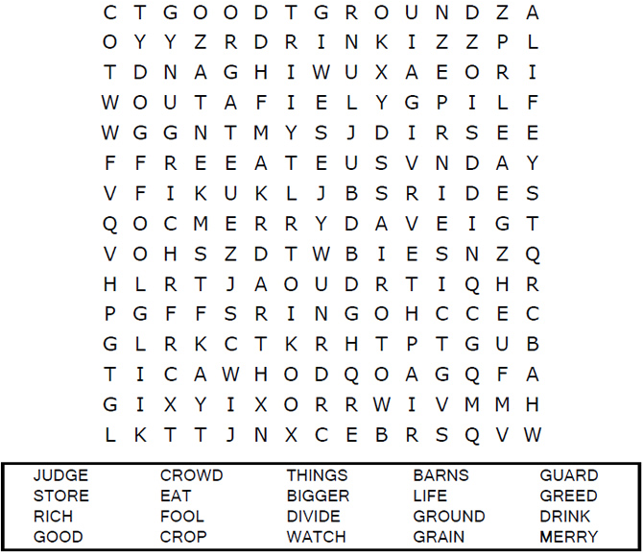
It’s Your Colouring Page to Print – Time to Relax
Print to use
"Then he said, 'This is what I'll do. I will tear down my barns
barns and build bigger ones, and there I will store
all my grain and my goods.’”
Luke 12:18 (NIV)

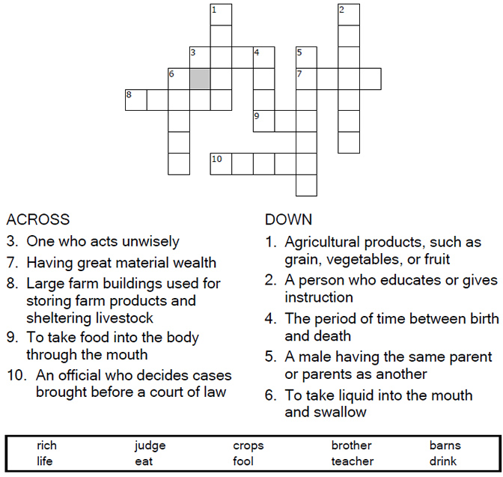

LAUGHTER IS GOOD FOR THE SOUL
LAUGH DOWN YOUR STRESSES
You have to laugh together, and sometimes laugh hard, at yourself, at a situation, at yourselves. Laugh with, but never at, each other...
Prov. 15:13 - A merry heart maketh a cheerful countenance...
Prov. 17:22 - A merry heart doeth good like a medicine

OUT OF THE MOUTH OF BABES
Author Unknown
A Sunday school teacher was teaching her class about the difference between right and wrong.
"All right children, let's take another example," she said. "If I were to get into a man's pocket and take his wallet with all his money, what would I be?"
Little Johnny raises his hand, and with a confident smile, he blurts out, "You'd be his wife!"

Got any “funnies” to share?? Email them to me for the next edition.

Where Is Your Heart?

They say “home is where the heart is” but is it really?
“Our heart is where we spend our time and money” is that really so?
Scripture says this: For where your treasure is, there your heart will be also. Luke 12:34
Jesus once said, "Where your treasure is, there will your heart be also." The heart is a symbol for love, isn't it? So what Jesus was saying is that you can tell what a person really loves by what he treasures the most. How do you know what a person treasures the most? Do you ask them what the most important thing is in their life? No, there are two ways you can tell what is most important to a person. The first is how they spend their money and the second is how they spend their time.
If we say that we love God, but spend every penny we have on ourselves, do we love God or self? If we say that we love God, but we never spend any time with Him, do we really love Him? Jesus said that we should love our neighbor as ourselves. If we say that we love our neighbor but we never share what God has given us with them, do we really love our neighbor? You don't learn what a person's treasure is by asking them. You learn by watching how they spend their time and their money. Look at the things you spend your time and money on and then ask yourself, "What do I treasure? Where is my heart?"
Dear Jesus, help us to make sure that our heart is in the right place. Help us to show our love for you and for one another in the way we spend our time and our money. In Jesus' name we pray,
Amen.
Copyright © 2001- 2012 Sermons4Kids, Inc. All Rights Reserved

Each number represents a letter of the alphabet. Substitute
the correct letter for the numbers to reveal the coded words.
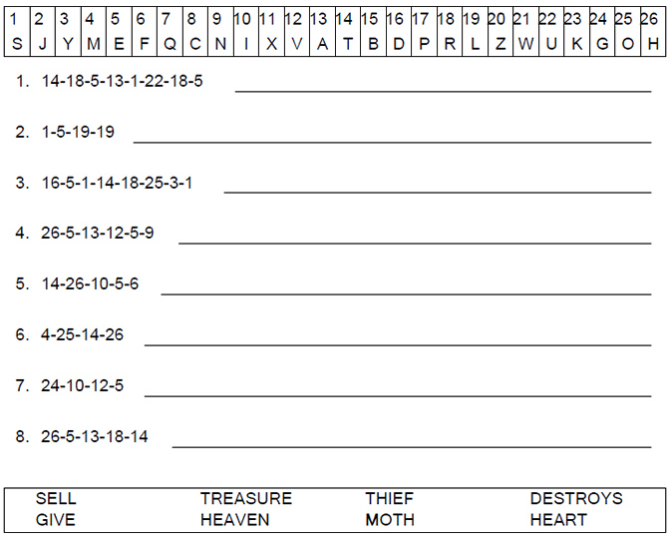
Copyright © 2001- 2012 Sermons4Kids, Inc. All Rights Reserved

Psalm 150:2
Praise Him for his mighty acts: praise Him according to His excellent greatness.

Jeff was beside himself. His wife had gone into labour hours ago, and a nurse had just come out to tell him that there were complications. There was a good chance that they might lose either the mother or the child. Jeff could only wait and pray. Time passed slowly, but when everything was finally done, both mother and child were fine, and Jeff prayed a silent prayer of thanks.
God does mighty acts in our lives. There are times when things don't always work out the way we want them, but God is there to pick us up and help us deal with our trials.
Praise the Lord that He is good and kind. His goodness is unending, and we are always in His care.

Prayer:
I cannot begin to understand all that You have done, Lord, but I praise You for what I have seen and felt. You have given so much. Thank You.
Amen.

There's Always Something I Can Do
Glynnis Whitwer
"Then Jesus directed them to have all the people sit down in groups on the green grass. So they sat down in groups of hundreds and fifties."
Mark 6:39-40 (NIV)
Devotion:
Worn out. Hungry. Without resources. Needs on every side. That's what Jesus' disciples faced at the end of a long day of ministry. Even Jesus was ready for a rest. So He suggested they go by boat to a solitary place. Great idea, right? Well, it didn't work out that way.
By that point in Jesus' ministry, people followed Him everywhere. In fact, they were so desperate for His touch, they ran around the lake, and actually got to the other side before Jesus did.
Imagine the disciples' response seeing all those needy people. I imagine they felt empty. Have you ever felt that way? ... exhausted by the demands on you ... emotionally bankrupt ... at the end of your resources with nothing left to give?
Just when the disciples wanted to curl up and rest, Jesus started to teach to the people. Didn't He notice they were exhausted? They wanted to do nothing, because that's all they thought they could do.
The disciples even tried to stop Jesus from teaching, and send the people away so they could do nothing in peace. They said, "This is a remote place ... and it's already very late. Send the people away so they can go to the surrounding countryside and villages and buy themselves something to eat" (Mark 6:35b-36).
So not only were the disciples exhausted, they were in a barren place with NO resources. I know what that feels like. There have been times in my life when needs faced me at every turn, circumstances and people thwarted my best efforts, and hope flickered like a weak flame. At those times, "nothing" seemed like all I could do.
On that day when the disciples felt they could not take on one more task, Jesus gave them a biggie. Instead of allowing them to send the people away, Jesus said, "You give them something to eat" (Mark 6:37).
Jesus then asked the disciples to present what food they had. It wasn't much, but they handed over five loaves of bread and two fish. Then Jesus told the disciples to have the people sit down in groups (v. 39).
While the disciples did that, Jesus thanked God for the food and gave it back to the disciples to pass around. Jesus worked a miracle that day, all the people were fed, and there were 12 baskets of food left.
I've read that story many times in my life, but recently something stood out to me. Why did Jesus ask the disciples to have the people sit? And why did they sit in groups? The most obvious answer is that in the face of an overwhelming situation, Jesus knew everybody needed order.
What if there was more than a need for simple order? What if Jesus wanted the disciples to shift their focus away from what they couldn't do, to what they could do? Then, Jesus did what only He could - He performed a miracle.
The disciples were so focused on their own lack, and how they couldn't possibly meet the overwhelming needs, they decided to do nothing. Worse than that, they forgot they were standing next to the One who could help. But Jesus put them to work on the practical task right before them, to prepare for the miracle He was about to perform.
As I face hard times in my own life, there is wisdom in this for me. Sometimes, all I think about is what I can't control. I focus on the problem and the unfairness of the situation. Even though I've prayed, confessed my needs and presented my resources to Jesus, I stay focused on what I can't do. It's a pretty limited view of the situation.
I somehow forget that I'm standing next to the One who can feed 5,000 people with five loaves and two fish ... and have leftovers! Sometimes, instead of doing what God has placed in front of me, I do nothing.
Perhaps, instead of wringing my hands with worry, I need to get busy with what I can control. There's always something I can do to bring order to my situation. It's not a distraction technique ... it's an act of faith. Jesus is still in the business of miracles, and I definitely can't do those.
Dear Lord, forgive me when I focus more on my own limitations rather than Your power. There is nothing too great for You. Help me to turn my thoughts away from what I can't do, to what You have placed in front of me. I trust You to do the rest. In Jesus' Name,
Amen.

Related Resources:
Do You Know the One Who Can Meet Your Needs?

Application Steps:
Identify a situation that has you frozen with inaction. Pick one thing you can do, and get started on it today.
Reflections:
What can I do to help myself overcome emotional exhaustion?
Why does doing a practical task sometimes help in overwhelming situations?

Power Verses:
Mark 6:42-44, "They all ate and were satisfied, and the disciples picked up twelve basketfuls of broken pieces of bread and fish. The number of the men who had eaten was five thousand." (NIV)
Psalm 46:1, "God is our refuge and strength, an ever-present help in trouble." (NIV)

© 2010 by Glynnis Whitwer. All rights reserved.
www.Proverbs31.org

God Is For You
by Max Lucado

Romans 8:31 asks, “If God is for us, who can be against us?”
Indulge me a moment. Four words in this verse deserve your attention. God is for us.
Say it out loud. God is for us.
Repeat it, emphasizing each word. Come on, you’re not in that big of a hurry.
God is for us! GOD IS FOR YOU.
Your parents may have forgotten you, your teachers may have neglected you, your siblings may be ashamed of you; but within reach of your prayers is the maker of the oceans. God!
God is for you! If he had a calendar, your birthday would be circled. If there’s a tree in heaven, he’s carved your name in the bark.
Isaiah 49:16 says, “I have written your name on my hand!” No one can defeat you. You are protected. God is for you!
from the Lucado Inspirational Reader

coutesy of maxlucado.com

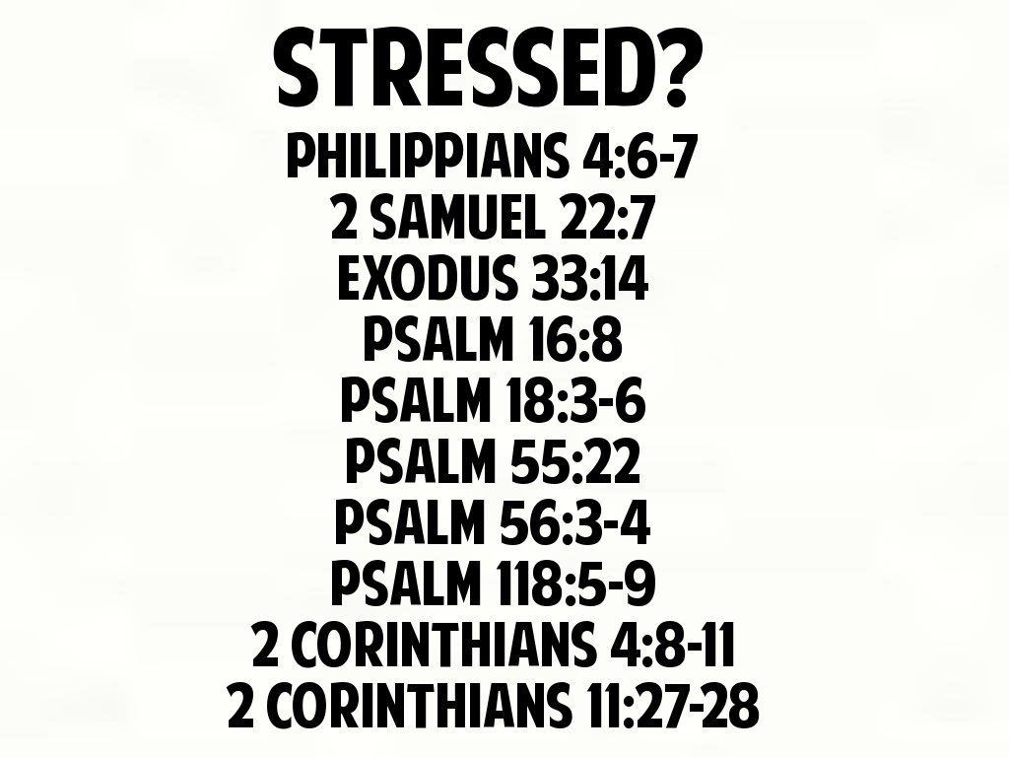

Accepting the Inevitable
Job 36:1--15
"But those who suffer he delivers in their suffering; he speaks to them in their affliction." (v. 15)

Oswald Chambers said: "Life is more tragic than orderly." Chambers knew that unless Christians are willing to grapple with this truth and accept it, they will be plagued by inner oughts and shoulds that lead them down the road of illusion. They will find themselves saying, "It ought not to be like this" or "Things should be different" -- and the only thing this kind of demandingness produces is frustration and anger. The Fall has turned this fair universe of God's into a shambles, and though much about the world is still beautiful, accidents, calamities, and suffering prevail. And these will continue until the time when God brings all things to a conclusion. There is nothing wrong with wishing that things were not so, but when we demand that they be different, when we say the effects of the Fall must be reversed and reversed now, we will end up feeling terribly frustrated. Life is difficult, as Scott Peck stated, and though prayer does move God to work supernaturally in some situations, life will go on being more "tragic than orderly" until Christ returns and finalizes His plans for this fallen planet. This is reality -- and the sooner we face it the better. True faith is not built upon illusion but upon reality. We may not like things the way they are in this world, but to avoid facing them because they don't match up with what we know about God is foolish. As I have been emphasizing, it is only when we face honestly the harsh realities of life that we become ready for God to speak to us.

Prayer:
O God, I see that facing the hard things of life honestly drives me to a place where I become desperate for an answer. Then You step in -- and give me not an answer but Yourself. I can live without answers, but I cannot live without You. Stay close to me, my Father. In Jesus' Name.
Amen.

For Further Study
Heb. 11:1--40; 2 Cor. 11:16--29; 4:7--10
1. What is faith?
2. List some of the difficult circumstances of life faced in the light of faith.

Salem Web Network | Copyright 2010. All rights reserved

Are you Seeking God? Or would you like to know more?

The Pastor/Minister of the church that you attend can assist.
Or if you wish to you can contact our Pastor - Reverend Stan Notice on 01246 551906.
Leave your contact details and someone from his office will get back to you as soon as possible.

At the New Testament Church of God in Chesterfield we worship each Sunday at 10:15am for Sunday school, 11:30 for Morning Worship and6:30pm for Evening Worship and on Tuesday evenings we meet for Prayer and Bible Study from 7.30pm.
We want to invite you to come visit us at our church. Our address is 7 Compton Street in Chesterfield near the old football ground.
Find us here
Thank you
&
May God bless you

